**Vue.js debugging in chrome and vscode Installation.**

* Make sure you have Google Chrome installed.
* Use Vue CLI to create a new vue.js app.
* cd into the newly created app directory and open VS Code.
* Install the “debugger for chrome” plug-in on VS Code.

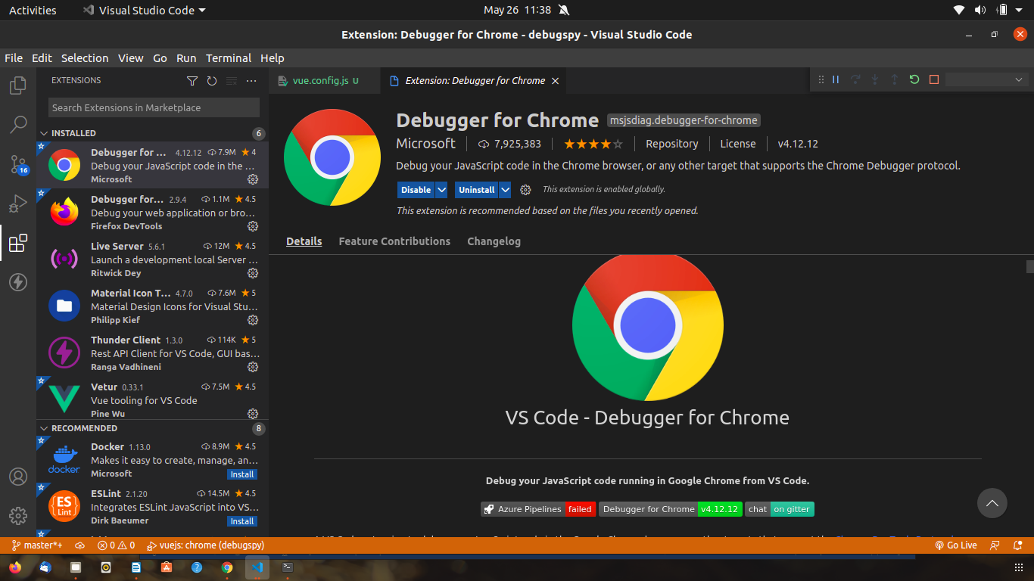

* Create a “vue.config.js” file in the root of your app directory and put the following code:

module.exports = { configureWebpack: { devtool: 'source-map' } }

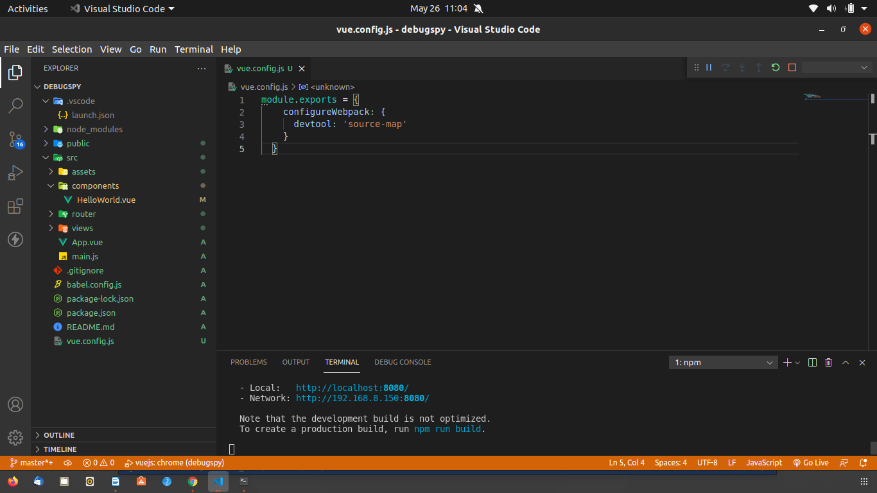

* Click on the debug icon on VS Code.

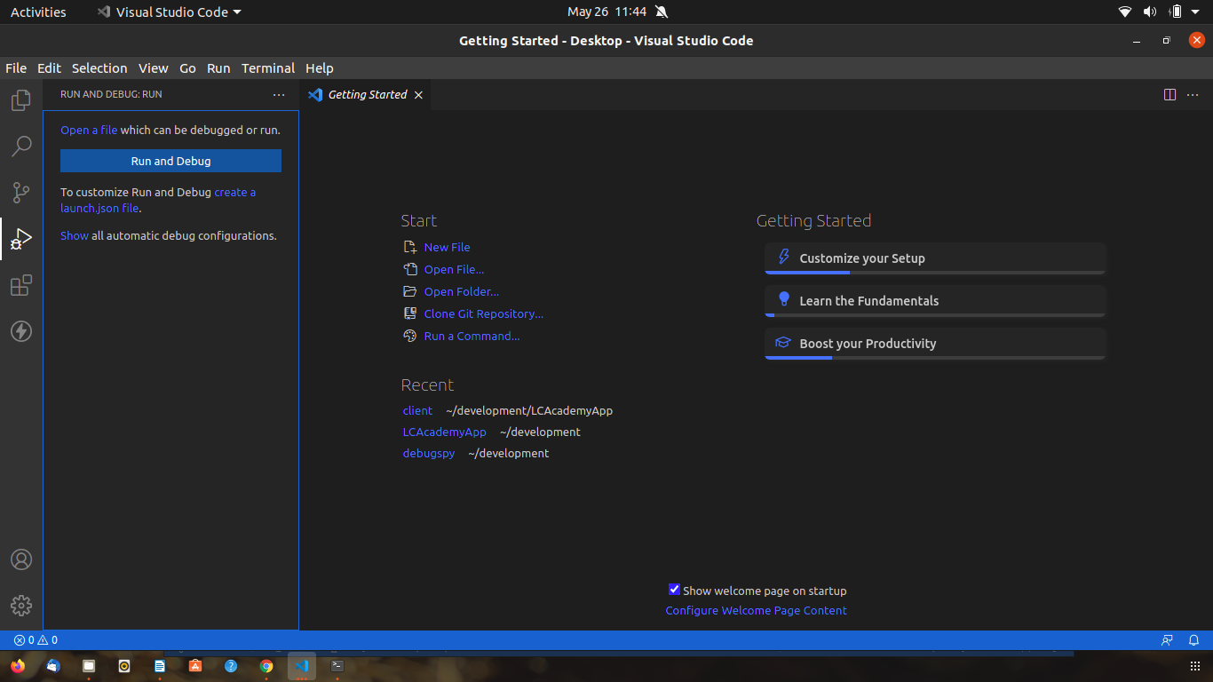

* Click on “create a launch.json file” then select Chrome

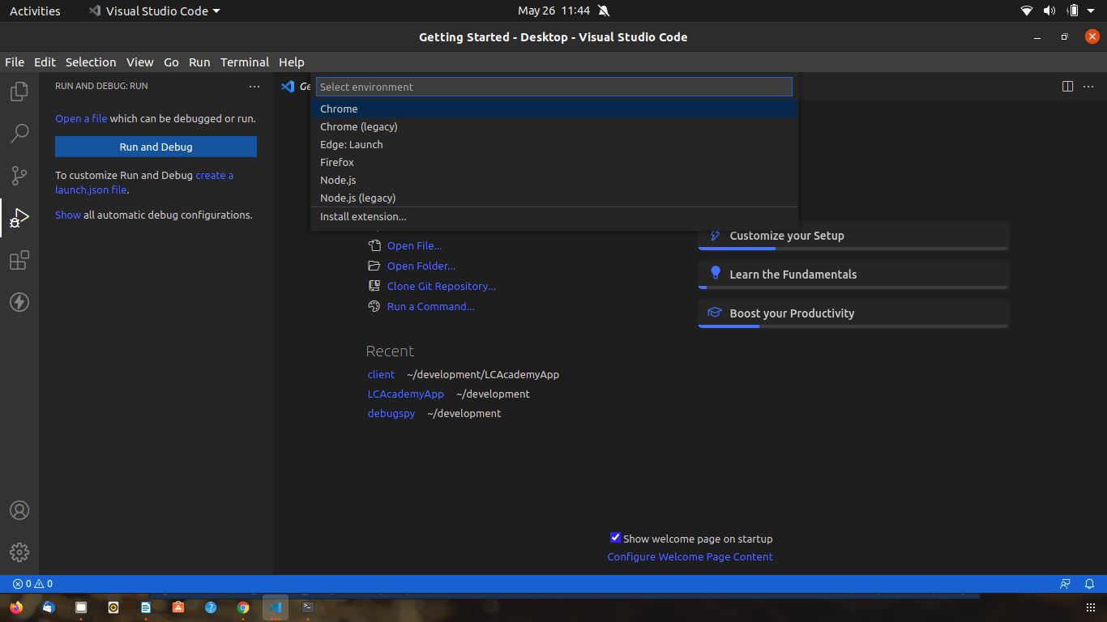

* After clicking Chrome edit the “launch.json” file that will show up with the following code:

"version": "0.2.0",

"configurations": [

{

"type": "chrome",

"request": "launch",

"name": "vuejs: chrome",

"url": "http://localhost:8080",

"webRoot": "${workspaceFolder}/src",

"breakOnLoad": true,

"sourceMapPathOverrides": {

"webpack:///src/*": "${webRoot}/*"

}

}

]

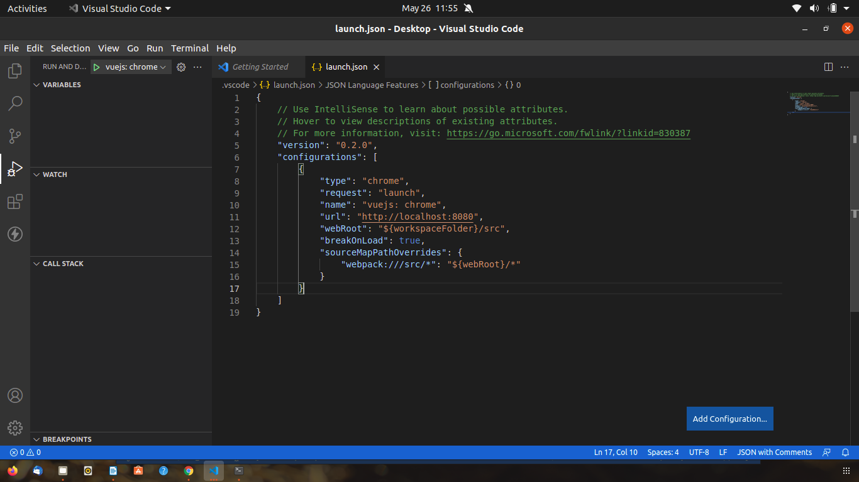

* Make sure you save all the files after you edit them.

**Vue.js debugging in firefox and vscode Installation.**

* Make sure you have Firefox installed.
* Use Vue CLI to create a new vue.js app.
* cd into the newly created app directory and open VS Code.
* Install the “debugger for firefox” plug-in on VS Code.
* 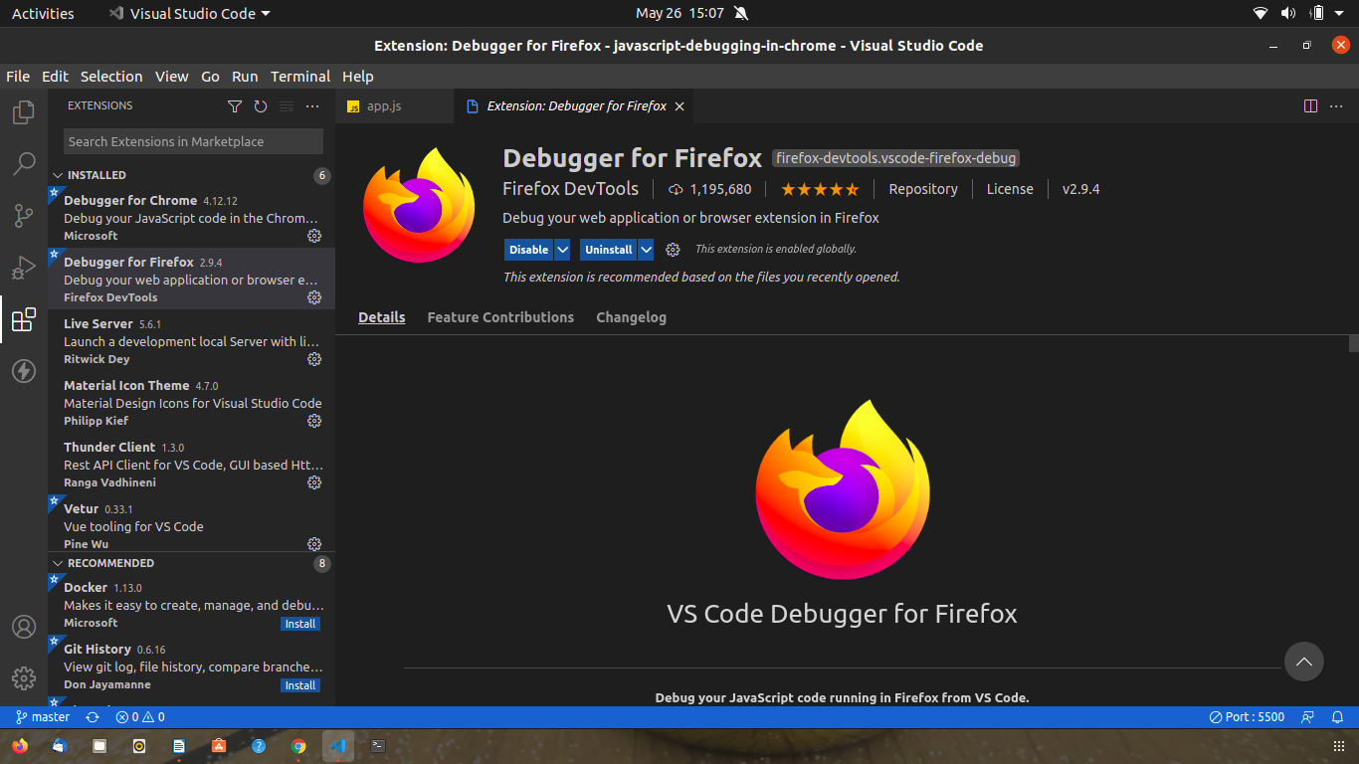Create a “vue.config.js” file in the root of your app directory and put the following code:

module.exports = { configureWebpack: { devtool: 'source-map' } }

* Click on the Debug icon on VS code
* Click on “create a launch.json file” then select Firefox
* After clicking Chrome edit the “launch.json” file that will show up with the following code:

"version": "0.2.0",

"configurations": [

{

"type": "firefox",

"request": "launch",

"name": "vuejs: firefox",

"url": "http://localhost:8080",

"webRoot": "${workspaceFolder}/src",

"pathMappings": [

{

"url": "webpack:///src/",

"path": "${webRoot}/"

}

]

}

]

* 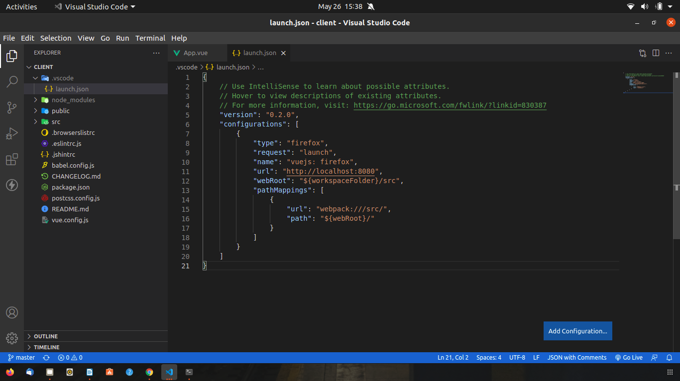Make sure you save all the files after you edit them.